SOFTWARE ENGINEERING
Assignment Submission
Project:
University Timetable Optimization and Management System
Assignment 1: Process Model Selection
Assignment 2: High-Level Use Cases

Subject: Software Engineering
Academic Year: 2025–2026

Assignment No. 1 — Process Model Selection
Project: University Timetable Optimization and Management System

1. Introduction
The proposed project is a web-based University Timetable Optimization and Management System. Its purpose is to automate the preparation, management, and publication of university timetables for multiple teachers, classes, rooms, and student groups. The system aims to reduce manual effort, eliminate scheduling conflicts, and allow timetable customization according to institutional policies and goals.
The system is expected to support configurable scheduling policies such as continuous classes for energy saving, morning-preference scheduling, early day ending to reduce fatigue, room-proximity preferences, traffic-reduction modes, holiday management, and teacher-specific adjustments without disrupting the wider schedule.

2. Project Requirements
The following requirements are identified for the proposed system:
- Maintain records of teachers, courses, rooms, sections, student groups, and timeslots.
- Record teacher availability, unavailable periods, and scheduling preferences.
- Maintain room capacities, room types, and room feature requirements.
- Define timetable constraints including hard rules and soft preferences.
- Generate a conflict-free timetable satisfying all hard constraints.
- Report constraint violations and timetable quality score after generation.
- Allow manual timetable adjustments without disturbing unrelated entries.
- Support custom institutional goals: continuous classes (electricity saving), morning classes (habit building / summer AC saving), early day ending (fatigue reduction), room proximity, and traffic-reduction modes.
- Support teacher-specific changes without cascading impact to other teachers.
- Manage holidays, blocked days, and institutional break periods.
- Publish filtered timetable views for teachers and student groups.
- Maintain version history and support timetable re-optimization after changes.

3. Selection Criteria
The following criteria were considered for the selection of a suitable process model:
- Requirement clarity and expected frequency of change
- Nature and complexity of the project domain
- Technical risk in optimization and constraint modules
- Need for prototype feedback on UI and timetable workflow
- Team size and available development time
- Documentation requirements for academic submission
- Frequency of stakeholder feedback during development
- Modular deliverability of system components
- Need for continuous testing across system modules
- Support for future feature extension (advanced algorithms, multi-campus)

4. Candidate Process Models Considered
The following process models were evaluated before making a final selection:

Model | Strengths for this Project | Limitations for this Project
Waterfall | Clear documentation; simple to plan; good for stable requirements | Does not support requirement changes; no feedback until final delivery; costly to repair late discoveries in constraint logic
Incremental | Modular delivery; early working builds; supports phased growth; works well when features can be separated into meaningful increments | Requires clear increment boundaries; integration across increments needs planning
Spiral | Strong risk management; suitable for high-uncertainty projects | Heavy process; difficult to manage in a semester-length project; overhead outweighs benefit at this scale
Agile Practices | Very fast feedback; continuous improvement; suits small teams | Weaker formal documentation; harder to satisfy academic submission structure; may drift in scope

5. Selected Process Model
The selected process model is the Incremental Process Model with Prototyping as a supporting technique.

Clarification of Terminology: The Incremental Process Model is the primary lifecycle governing the development sequence. Prototyping is not a second process model; it is a supporting technique applied within the early increments to validate user interfaces, timetable screens, and rule configuration workflows before committing to full implementation. This is academically more precise than treating prototyping as a co-equal model.

5.1 Model Overview
The Incremental Process Model divides the software system into smaller functional modules. Each module is developed in a distinct increment, and each increment delivers a testable, working portion of the system. Development proceeds through analysis, design, build, and test phases within every increment, with a feedback loop allowing discoveries from each increment to inform the next.
For this project, the system is divided into five increments:
- Increment 1 — Master data and resource setup: departments, courses, teachers, rooms, sections, timeslots.
- Increment 2 — Constraints and policy configuration: availability, hard rules, soft preferences, policy toggles.
- Increment 3 — Initial timetable generation MVP: solver integration, feasibility checking, basic score.
- Increment 4 — Review, repair, and controlled re-optimization: conflict display, manual adjustment, minimal-disruption updates.
- Increment 5 — Publication and operational reporting: teacher/student views, room reports, export.
An early prototype of the timetable screens and constraint configuration forms will be used inside Increments 1 and 2 to validate the design with the supervisor before full implementation.

5.2 Process Model Weighted Evaluation Matrix
The table below shows how the key criteria were scored for each model (0 = poor fit, 5 = excellent fit). Criterion weights reflect the relative importance of each factor for this specific project.

Criterion | Wt | Waterfall | Incremental | Spiral | Agile | W×Inc | W×Spi | W×Agi
Requirement volatility | 5 | 1 | 4 | 3 | 5 | 20 | 15 | 25
Visual/prototype feedback | 4 | 1 | 4 | 4 | 5 | 16 | 16 | 20
Technical risk (solver) | 4 | 2 | 4 | 5 | 3 | 16 | 20 | 12
Modular deliverability | 4 | 2 | 5 | 3 | 4 | 20 | 12 | 16
Documentation quality | 3 | 5 | 4 | 3 | 2 | 12 | 9 | 6
Semester time fit | 3 | 3 | 4 | 2 | 4 | 12 | 6 | 12
Future extensibility | 3 | 2 | 5 | 3 | 4 | 15 | 9 | 12
TOTAL WEIGHTED SCORE |  |  |  |  |  | 111 | 87 | 103

The Incremental Model scores highest (111) because it best handles the combination of volatile requirements, modular structure, prototype feedback needs, and documentation standards required for this project.

5.3 Justifications

5.3.1 Requirements are not fully frozen at the outset
University timetable systems have requirements that emerge progressively. Policy choices such as energy-saving compaction, morning preference, room-proximity weighting, and traffic-reduction modes are often only specified by stakeholders after they observe a draft timetable. This behavior is structurally incompatible with a Waterfall lifecycle, where requirement freezing precedes all design and construction. The Incremental Model allows these requirements to be introduced at appropriate increment boundaries.

5.3.2 The optimization module carries technical uncertainty
The timetable generation and constraint-satisfaction component is not a standard CRUD feature. It involves solver integration, constraint weighting, violation detection, and re-optimization after changes. These carry real technical risk. By developing the solver module in Increment 3, the team can isolate and validate it after the data model is stable, reducing the risk of architectural misalignment.

5.3.3 Early prototype validates the most difficult design decisions
A timetable system is highly visual and policy-driven. Users often cannot articulate their real requirements until they see a draft timetable, a constraint configuration screen, or a conflict report. A prototype in Increments 1 and 2 provides this early visibility at low cost, before substantial implementation work is committed.

5.3.4 Increment boundaries align with natural system modules
The five proposed increments correspond directly to the natural layers of the system: data, rules, generation, review/repair, and publication. This means each increment delivers a genuinely usable capability rather than a partial subsystem. Stakeholders and supervisors can review working software after each stage.

5.3.5 Repair-after-change is a late-stage behavior
Real timetabling systems support minimal-disruption updates: when a teacher requests a change, the system should adjust the affected class while preserving as much of the accepted schedule as possible. This behavior is easier to introduce in Increment 4 after earlier increments have validated the generation logic. A Waterfall model would require this to be specified fully upfront, which is impractical.

5.3.6 Documentation is still maintained throughout
The Incremental Model does not sacrifice documentation. Requirements, design updates, data models, use cases, test cases, and screenshots can all be produced after each increment. This makes the model compatible with software engineering coursework standards.

6. Why Waterfall is Not Selected
The Waterfall model is appropriate when requirements are mature, stable, and unlikely to change. This project does not satisfy that precondition. Timetabling constraint rules, soft-preference weights, and institutional policy toggles are likely to evolve as the team, supervisor, or stakeholders see early outputs. In Waterfall, such changes discovered late require expensive redesign and regression. Furthermore, the timetable generation module is technically uncertain, and Waterfall offers no mechanism to isolate or early-validate high-risk components before the late integration phase.

7. Why Spiral Model is Not Selected
The Spiral Model would be appropriate if the project were large-scale, long-term, and had significant unknowns across many dimensions. For a semester project, the Spiral overhead (formal risk analysis per cycle, management overhead, full cost-benefit cycles) is disproportionate. The Incremental Model achieves the core benefit of phased development with far less process weight. The project is not risky enough to require full Spiral discipline.

8. Conclusion
The Incremental Process Model with Prototyping as a supporting technique is the most suitable process model for the University Timetable Optimization and Management System. It accommodates changing requirements, reduces technical risk through phased delivery, allows early validation via prototype, supports continuous testing, and maintains documentation standards throughout. It is directly appropriate for a modular web-based system of this complexity and academic scope.

9. Process Model Diagram

Figure 1 below shows the selected Incremental Process Model diagram for this project.

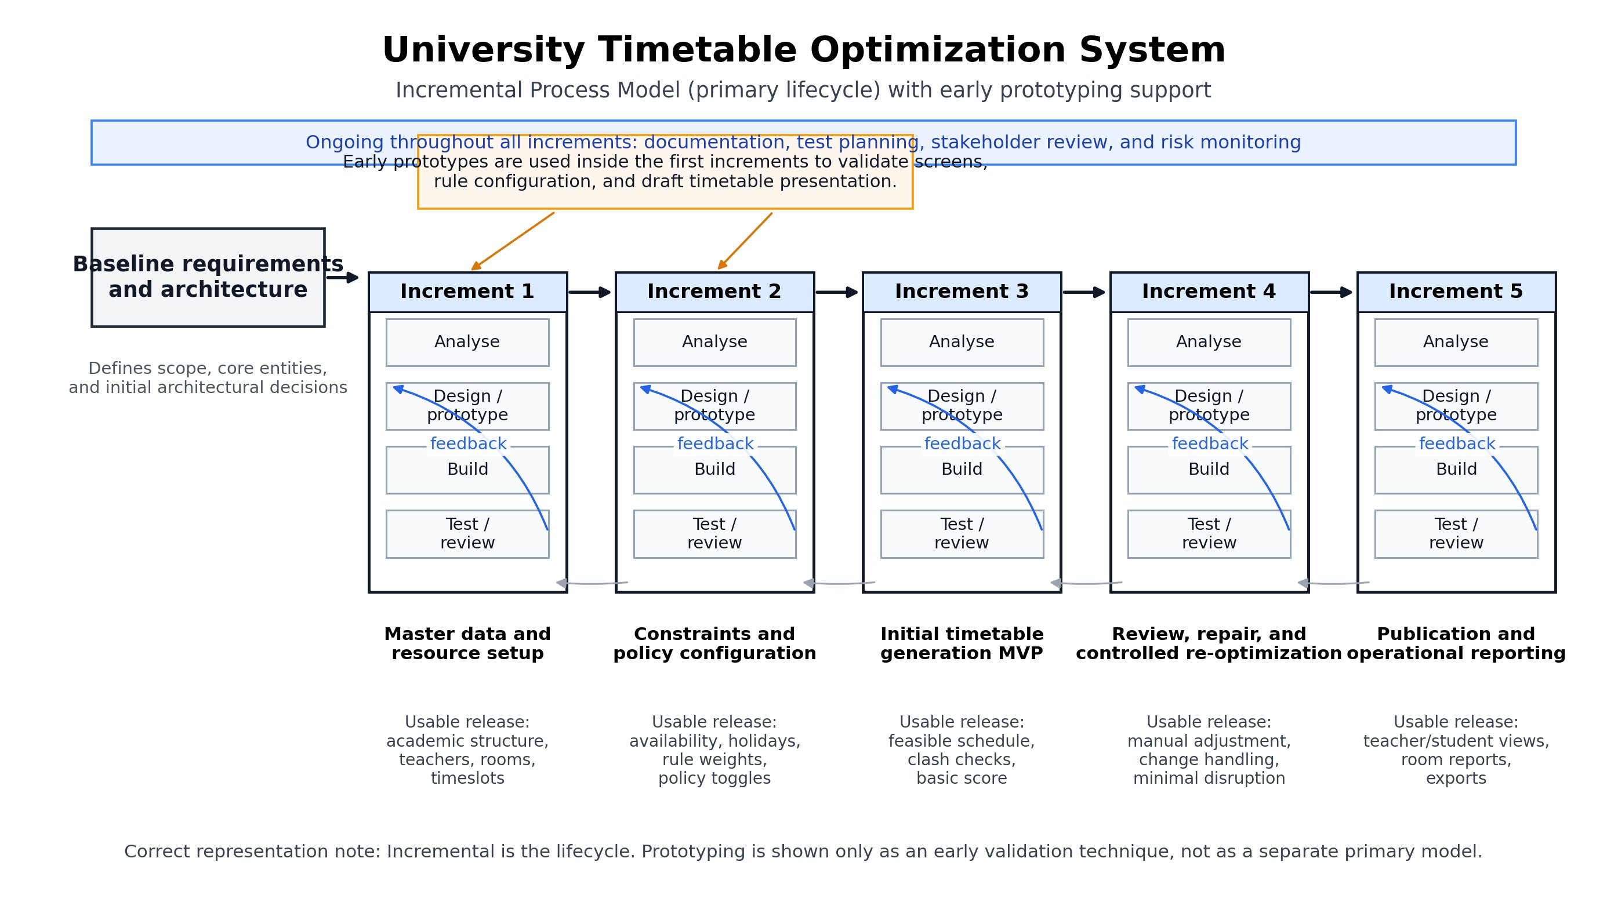
Figure 1: Incremental Process Model — University Timetable Optimization and Management System

Diagram Description
The diagram illustrates the Incremental Process Model selected as the primary lifecycle for the University Timetable Optimization and Management System.
The diagram begins on the left with a Baseline Requirements and Architecture box. This initial phase establishes the project scope, core domain entities, and architectural decisions before any increment begins. The output of this phase informs all subsequent increments.
Following the baseline, five increments are shown in a left-to-right sequence, each represented by a vertical column of four sub-phases: Analyse, Design/Prototype, Build, and Test/Review. Curved blue feedback arrows run from the bottom of each column back to the Design/Prototype sub-phase, indicating that testing and review within each increment can trigger design revisions before the next increment begins. This feedback loop is a key feature of the model.
Increment 1 delivers master data and resource setup, including academic structure, teachers, rooms, and timeslots. Increment 2 adds constraints and policy configuration, including availability, rule weights, and institutional policy toggles. Increment 3 produces the Initial Timetable Generation MVP, delivering the first feasible schedule with clash checks and a basic quality score. Increment 4 extends the system with review, repair, and controlled re-optimization features including manual adjustment and minimal-disruption updates. Increment 5 completes the system with publication features, teacher and student timetable views, room reports, and data exports.
Orange annotation arrows at the top of the diagram connect a note box to Increments 1 and 2, stating that early prototypes are used inside these increments to validate screens, rule configuration, and draft timetable presentation. This annotation clarifies that prototyping is a supporting technique used within the incremental lifecycle rather than a separate model.
A blue banner spanning the full width at the top of the diagram carries the label: Ongoing throughout all increments: documentation, test planning, stakeholder review, and risk monitoring. This communicates that documentation and quality activities are not deferred to the end but run in parallel with all increments.
A note at the bottom of the diagram states: Correct representation — Incremental is the lifecycle; Prototyping is shown only as an early validation technique, not as a separate primary model.
Overall, the diagram shows a modular, sequential, and feedback-supported development structure in which each increment builds on the previous one, early prototyping reduces rework risk, and documentation is maintained continuously throughout the project.

Assignment No. 2 — High-Level Use Cases
Project: University Timetable Optimization and Management System

1. Introduction
The University Timetable Optimization and Management System is a web-based platform that automates the creation, management, and publication of university timetables. The system serves multiple stakeholders including scheduling administrators, department coordinators, teachers, students, and facility managers. It supports constraint-based timetable generation, conflict reporting, manual adjustment, and publication with configurable institutional policies.
This section presents the high-level use cases of the system. Use cases are expressed at a goal level without detailed flow steps; expanded use-case specifications will be developed in a subsequent phase.

2. Actors
The following actors interact with the system:

Actor | Type | Role in the System
Timetable Administrator | Primary | Manages all master data, defines constraints, generates timetables, reviews results, makes adjustments, and publishes the final schedule.
Department Coordinator | Supporting | Validates data for the department, submits preferences and change requests, and participates in timetable review.
Teacher | Primary | Views personal timetable, provides availability preferences, and requests schedule adjustments when required.
Student | Primary | Views the published timetable for the assigned section, semester, or student group.
Facility Manager | Supporting | Maintains room records, updates room features and availability, and reviews room utilization reports.

3. System Context Diagram

The system context diagram below shows the boundary of the University Timetable Optimization and Management System and identifies all external actors that interact with it.

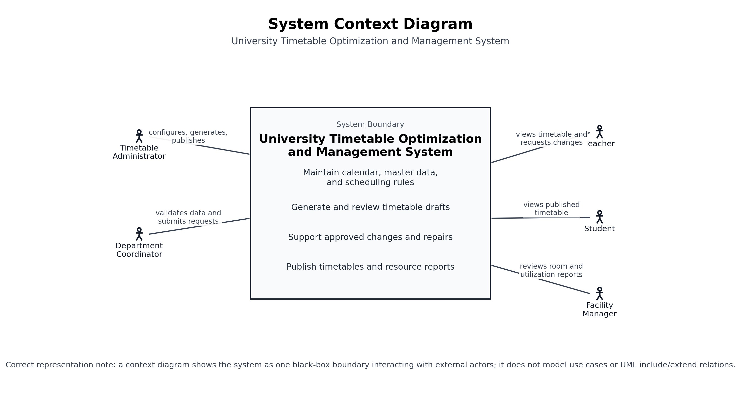
Figure 2: System Context Diagram — University Timetable Optimization and Management System

Diagram Description
The system context diagram presents the University Timetable Optimization and Management System as a single black-box entity bounded by a rectangular system boundary. This representation follows standard context-diagram conventions: the system is shown as one unit without internal decomposition, while all external actors and their interactions are shown outside the boundary.
On the left side of the boundary, the Timetable Administrator connects with the label configures, generates, and publishes, indicating that this actor is responsible for the full lifecycle of timetable management from data entry through to final publication. Below the administrator, the Department Coordinator connects with the label validates data and submits requests, reflecting the coordinator role as a data-quality supporter and change requester rather than a primary operator.
On the right side of the boundary, the Teacher connects with the label views timetable and requests changes, indicating that the teacher role is operational: viewing assigned schedules and requesting adjustments. Below the teacher, the Student connects with the label views published timetable, confirming that students are read-only end users of the published output. At the bottom right, the Facility Manager connects with the label reviews room and utilization reports, showing that this actor interacts primarily with resource-level reporting rather than schedule generation.
Inside the system boundary, four functional areas are listed as internal responsibilities: Maintain calendar, master data, and scheduling rules; Generate and review timetable drafts; Support approved changes and repairs; and Publish timetables and resource reports. These labels describe the system's main internal capabilities without modeling individual use cases or UML include/extend relations, which are reserved for the use case diagram.
A footnote at the bottom of the diagram states: a context diagram shows the system as one black-box boundary interacting with external actors; it does not model use cases or UML include/extend relations. This note reinforces that the context diagram serves a different modeling purpose than the use case diagram.

4. High-Level Use Cases

UC01 — Maintain Academic Calendar
Field | Detail
Use Case | Maintain Academic Calendar
Actors | Timetable Administrator (Primary); Department Coordinator (Supporting)
Type | Primary
Description | The administrator records and manages the academic calendar including semester dates, teaching days, working hours per day, holidays, institutional breaks, blocked days, and exam periods. This data forms the foundational constraint for all timetable generation. Holiday and blocked-day management is handled within this use case rather than as a separate function.
Essential | Establish and maintain the valid scheduling window and all restricted periods for a semester.
Real | The administrator opens the calendar configuration screen, enters the semester start and end dates, marks national holidays and Eid breaks, adds exam-week restrictions, and saves. The system validates the entries and prevents timetable generation from scheduling classes in any blocked period.

UC02 — Manage Master Data
Field | Detail
Use Case | Manage Master Data
Actors | Timetable Administrator (Primary); Department Coordinator (Supporting); Facility Manager (Supporting)
Type | Primary
Description | The administrator maintains all foundational scheduling data: departments, programs, courses, class sections, student groups or curricula, teachers, rooms, room features, buildings, and available timeslots. This data must be complete and validated before any timetable can be generated.
Essential | Maintain all resource and entity records that the scheduling system will use during timetable generation.
Real | The administrator adds a new room (Room 204, capacity 60, projector, ground floor), assigns a teacher to a course, and creates a new student group for Semester 3 Computer Science. The department coordinator validates that all course assignments are correct before generation is started.

UC03 — Define Constraints and Preferences
Field | Detail
Use Case | Define Constraints and Preferences
Actors | Timetable Administrator (Primary); Department Coordinator (Supporting)
Type | Primary
Description | The administrator defines the hard constraints and soft preferences that govern timetable generation. Hard constraints represent rules that must never be violated. Soft preferences represent goals that the system should try to satisfy and can be weighted. Institutional policy modes are also configured here.
Essential | Specify the scheduling rules and optimization goals that determine both feasibility and quality of the generated timetable.
Real | The administrator enables hard rules: no teacher clash, no room double-booking, all sessions must be scheduled, lab courses require lab rooms. The administrator then configures soft preferences: morning-class preference weight = 4, continuous-class compaction weight = 3, room-proximity weight = 2, early-ending target = 4:00 PM, and selects Traffic-Reduction Mode for Fridays.

UC04 — Generate Timetable
Field | Detail
Use Case | Generate Timetable
Actors | Timetable Administrator (Primary)
Type | Primary
Description | The administrator initiates timetable generation. The system reads all master data, constraints, and preferences, executes the scheduling engine, and produces a draft timetable that assigns each class session to a valid timeslot and room. The result is stored as a new draft version.
Essential | Produce a draft timetable that satisfies all hard constraints and optimizes soft preferences.
Real | The administrator selects the semester, confirms the active constraint configuration, and clicks Generate Timetable. The system processes all courses, teachers, rooms, and rules and returns a weekly timetable with a feasibility status, hard constraint pass/fail summary, and soft-constraint quality score.

UC05 — Review Timetable Quality
Field | Detail
Use Case | Review Timetable Quality
Actors | Timetable Administrator (Primary); Department Coordinator (Supporting)
Type | Primary
Description | After generation, the administrator reviews the draft timetable to check for hard constraint violations, soft constraint penalties, teacher load distribution, room utilization, and policy compliance. The system provides a structured conflict report and a score breakdown.
Essential | Evaluate whether the generated timetable is feasible and acceptable before any publication or manual editing.
Real | The administrator opens the generated timetable and views the conflict panel: zero hard violations, soft score of 87 points, compactness penalty of 24, and two rooms underutilized. The department coordinator checks that all required course sessions for their department are present and correctly assigned.

UC06 — Request Timetable Change
Field | Detail
Use Case | Request Timetable Change
Actors | Teacher (Initiator); Department Coordinator (Initiator); Timetable Administrator (Supporting)
Type | Primary
Description | A teacher or department coordinator submits a formal request to change one or more timetable entries. The request records the reason, scope, and priority. It is stored for administrator review and does not modify the timetable automatically.
Essential | Provide a structured channel for teachers and coordinators to request timetable modifications without directly editing the schedule.
Real | A teacher logs in, navigates to Schedule Requests, and submits a request to move Thursday Period 3 lecture to Monday Period 2, citing a departmental seminar conflict. The administrator receives the request, reviews it, and decides whether to approve and apply the change.

UC07 — Adjust and Re-optimize Timetable
Field | Detail
Use Case | Adjust and Re-optimize Timetable
Actors | Timetable Administrator (Primary)
Type | Primary
Description | The administrator applies approved changes to the timetable, either by manually editing individual entries or by triggering a re-optimization run. The re-optimization attempts to resolve the change with minimal disruption to already accepted class assignments. Selected entries can be locked to protect them from further automated changes.
Essential | Allow controlled modification and repair of the timetable after generation, while preserving as much of the accepted schedule as possible.
Real | The administrator approves the teacher's request, locks the 14 unaffected entries, and triggers re-optimization for the affected course. The system finds a valid new slot and updates only the impacted class without disturbing other teachers or student groups.

UC08 — Publish Timetable
Field | Detail
Use Case | Publish Timetable
Actors | Timetable Administrator (Primary)
Type | Primary
Description | Once the timetable has been reviewed, adjusted, and approved, the administrator publishes it as the official schedule for the semester. The published version becomes visible to teachers and students. Previous draft versions are retained in version history.
Essential | Release the approved timetable for official use by all system stakeholders.
Real | The administrator marks the current draft as Published. The system records the publication timestamp, locks the schedule from further automatic editing, and makes it accessible on teacher and student dashboards.

UC09 — View Personal Timetable
Field | Detail
Use Case | View Personal Timetable
Actors | Teacher (Primary); Student (Primary)
Type | Primary
Description | Teachers and students view the published timetable filtered to their specific context. A teacher sees the teaching load: courses, rooms, days, and times. A student sees the section schedule: subjects, rooms, and teachers. Both can navigate by week and export or print the timetable.
Essential | Provide each stakeholder with a filtered view of the published schedule relevant to their role.
Real | A teacher logs in and sees a weekly grid showing Monday 8:00–9:30 Database Systems, Room 204; Tuesday 10:00–11:30 Software Engineering, Room 101; and so on. A student from Semester 3 Section A views the same system but sees only their section's schedule.

UC10 — View Resource Reports
Field | Detail
Use Case | View Resource Reports
Actors | Timetable Administrator (Primary); Facility Manager (Primary)
Type | Primary
Description | The system provides operational reports including room-by-room occupancy, peak traffic periods, teacher load distribution, compactness scores, late-day class frequency, and energy-policy compliance. These reports support administrative review and long-term scheduling decisions.
Essential | Provide administrators and facility managers with quantitative data on resource utilization and policy compliance in the published timetable.
Real | The facility manager opens the Room Utilization Report, which shows Lab A at 78% utilization, three rooms at below 40% utilization, and two peak congestion periods. The administrator uses this data to decide whether to re-balance rooms in the next semester.

5. Use Case Diagram

Figure 3 below shows the High-Level UML Use Case Diagram for the University Timetable Optimization and Management System.

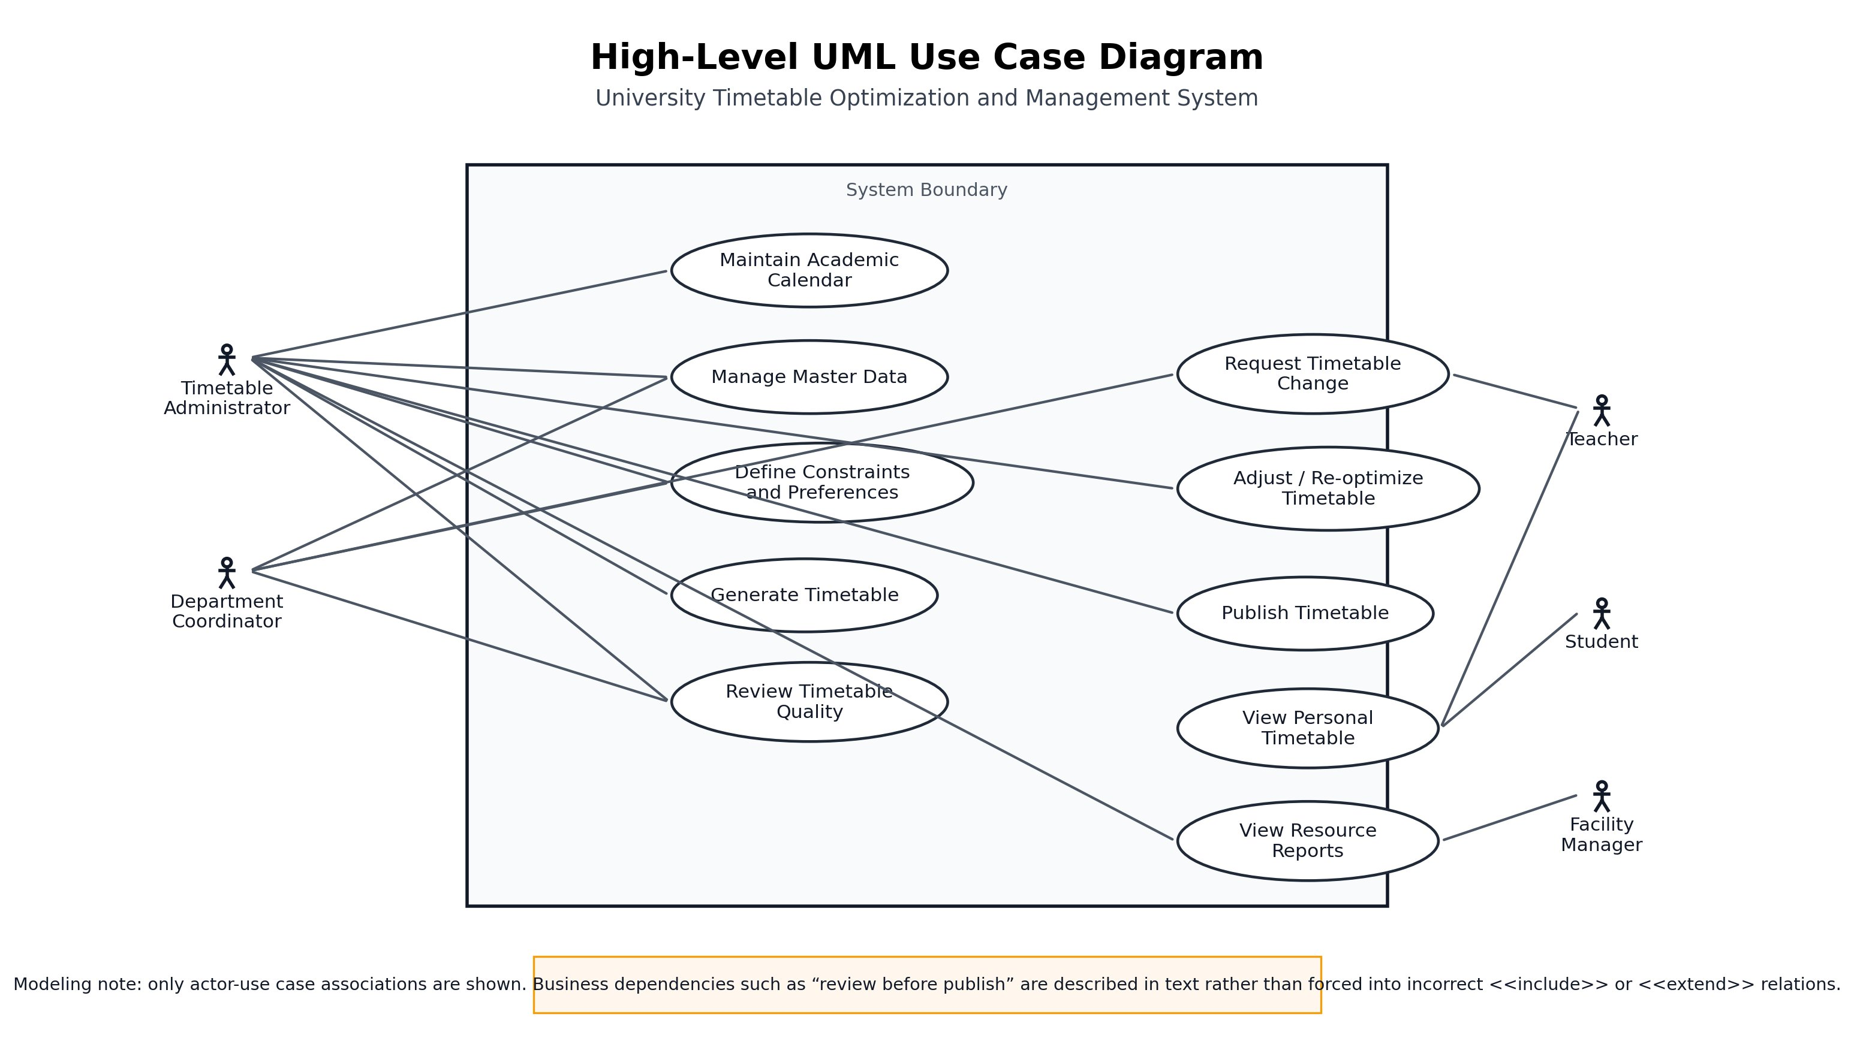
Figure 3: High-Level UML Use Case Diagram — University Timetable Optimization and Management System

Diagram Description
The diagram shows the High-Level UML Use Case Diagram for the University Timetable Optimization and Management System. It uses standard UML notation with stick-figure actors outside a rectangular system boundary and oval use cases inside.
The system boundary rectangle is labeled System Boundary and contains ten use-case ovals representing the primary functional goals of the system. The boundary clearly separates internal system behavior from external actors.
On the left side of the diagram, two actors are shown: the Timetable Administrator and the Department Coordinator. The Timetable Administrator is the most connected actor and has associations to the majority of use cases including Maintain Academic Calendar, Manage Master Data, Define Constraints and Preferences, Generate Timetable, Review Timetable Quality, Adjust/Re-optimize Timetable, Publish Timetable, and View Resource Reports. The Department Coordinator has associations to Manage Master Data, Define Constraints and Preferences, Review Timetable Quality, and Request Timetable Change.
On the right side, three actors are shown: Teacher, Student, and Facility Manager. The Teacher is associated with Request Timetable Change and View Personal Timetable. The Student is associated only with View Personal Timetable. The Facility Manager is associated with View Resource Reports.
The use cases are arranged in two columns inside the boundary. The left column holds the core administrative use cases: Maintain Academic Calendar, Manage Master Data, Define Constraints and Preferences, Generate Timetable, and Review Timetable Quality. The right column holds operational use cases: Request Timetable Change, Adjust/Re-optimize Timetable, Publish Timetable, View Personal Timetable, and View Resource Reports.
A note at the bottom of the diagram reads: Modeling note: only actor-use case associations are shown. Business dependencies such as review before publish are described in text rather than forced into incorrect include or extend relations. This note is intentional and reflects a correct UML modeling decision. The dependency between Review Timetable Quality and Publish Timetable is a business-process ordering constraint, not a UML include or extend relation, and representing it as one would be semantically incorrect. The diagram therefore shows only valid UML associations.

6. Use Case Summary Matrix

ID | Use Case | Type | Primary Actor | Goal
UC01 | Maintain Academic Calendar | Primary | Admin | Establish the valid scheduling window including holidays and blocked days.
UC02 | Manage Master Data | Primary | Admin | Maintain all resource and entity records needed for generation.
UC03 | Define Constraints and Preferences | Primary | Admin | Specify hard rules and weighted soft goals governing timetable quality.
UC04 | Generate Timetable | Primary | Admin | Produce a draft timetable satisfying all constraints.
UC05 | Review Timetable Quality | Primary | Admin | Evaluate feasibility and quality before acceptance.
UC06 | Request Timetable Change | Primary | Teacher / Coord. | Submit a structured change request without direct schedule modification.
UC07 | Adjust and Re-optimize Timetable | Primary | Admin | Apply approved changes with minimal disruption to existing assignments.
UC08 | Publish Timetable | Primary | Admin | Release the approved timetable for official stakeholder use.
UC09 | View Personal Timetable | Primary | Teacher / Student | Access a role-filtered view of the published schedule.
UC10 | View Resource Reports | Primary | Admin / Facility Mgr | Review room utilization, traffic, and policy compliance data.

7. Notes on Modeling Decisions
The following decisions were made deliberately and can be justified against standard use-case modeling principles:
- Holidays and blocked days are included within UC01 (Maintain Academic Calendar) rather than as a separate use case. This avoids redundancy because holiday management is part of the same administrative configuration activity as semester dates and working hours.
- Teacher change requests (UC06) are separated from administrator-performed timetable adjustment (UC07). The teacher and coordinator are initiators who submit requests; the administrator is the actor who approves and executes modifications. Combining these into one use case would blur the actor-role boundary.
- Manual locking of specific class assignments is treated as an internal behavior within UC07 rather than a standalone high-level use case. At the goal level, locking is a mechanism used during adjustment, not an independently initiated user goal.
- UML include and extend relationships are deliberately omitted from the use case diagram. The business-process ordering between review, adjustment, and publication is described in text because forcing these into include or extend relations would misrepresent their semantics. Include requires the base use case to invoke the included one at runtime; this is not true of review-before-publish, which is a workflow constraint, not a use-case decomposition.

8. Conclusion
The ten high-level use cases presented above collectively define the functional scope of the University Timetable Optimization and Management System. They cover the full timetable management lifecycle from calendar definition and data entry through constraint configuration, generation, review, adjustment, publication, and reporting. The actor model cleanly separates the administrative, operational, and read-only roles. The use case set is non-overlapping, maintained at a consistent high-level abstraction, and directly traceable to the project requirements identified in Assignment 1.

References
Sommerville, I. (2016). Software Engineering (10th ed.). Pearson Education.
Pressman, R. S., and Maxim, B. R. (2015). Software Engineering: A Practitioner's Approach (8th ed.). McGraw-Hill.
Larman, C. (2005). Applying UML and Patterns: An Introduction to Object-Oriented Analysis and Design (3rd ed.). Prentice Hall.
ITC-2007: International Timetabling Competition 2007, Curriculum-Based Course Timetabling. Available: https://www.cs.qub.ac.uk/itc2007/
UniTime: University Timetabling Application. Available: https://www.unitime.org/

